For immediate release
NEW 'Student Health App' to support students and universities
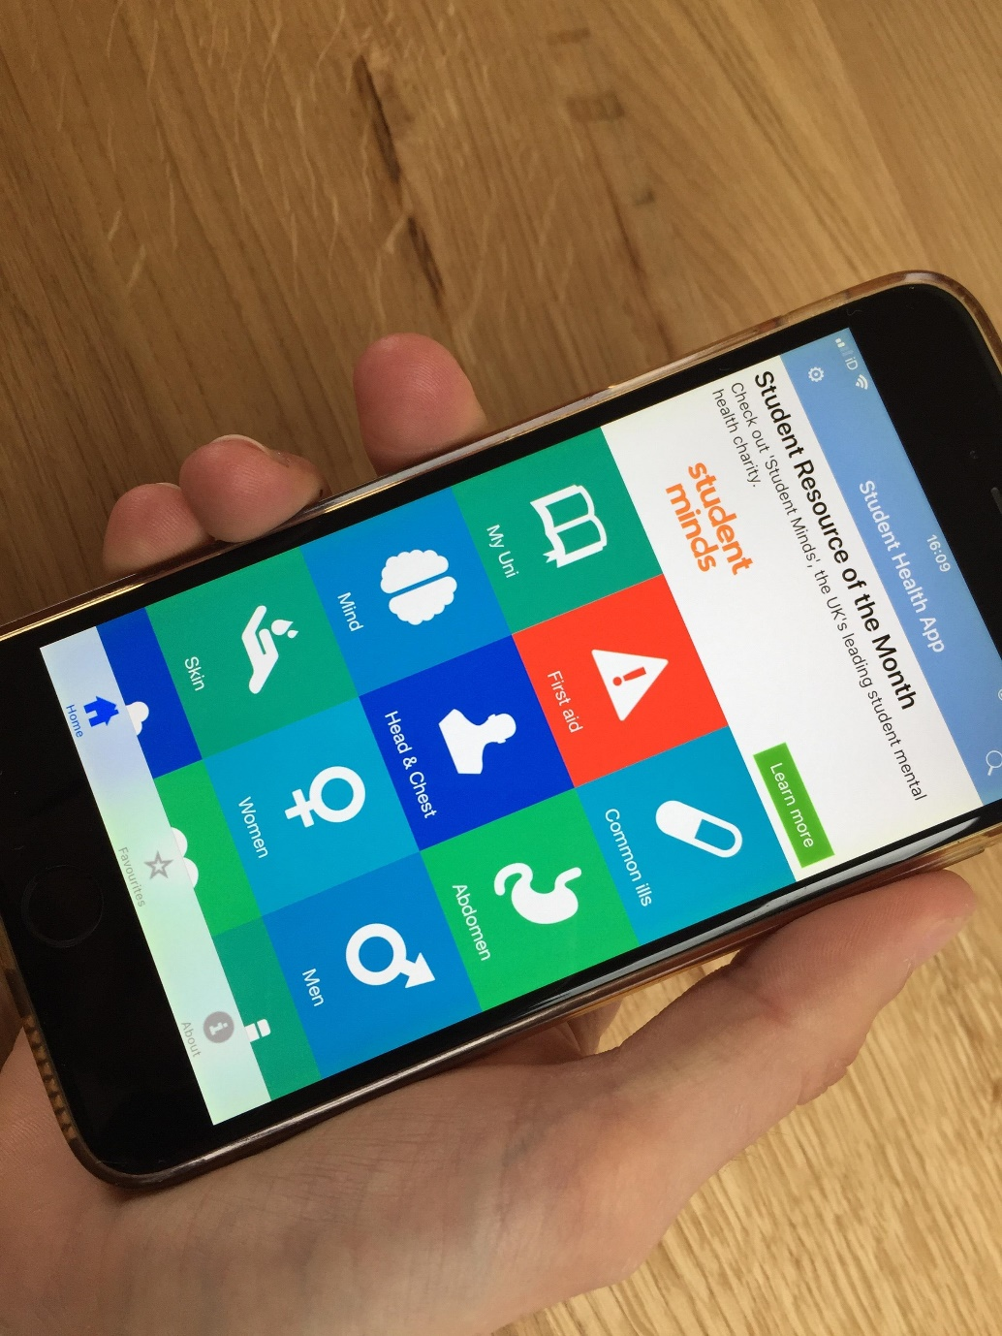
A newly re-designed app is now available to empower university students to take better care of their health. Providing relevant and reliable information on over 150 mental and physical health issues, the FREE 'Student Health App' (previously known as 'ESC Student') allows students to make informed decisions about their health and helps them flourish at university.

WHY DEVELOP THIS APP? Student wellbeing and mental health are in crisis. Over the past 10 years, the proportion of students with mental health problems has risen five-fold, according to the Institute for Public Policy Research. Student suicide numbers are rising, and Universities UK recognise student mental health as a national priority.
Student mental health is also being addressed in parliament, and MP Helen Whately asked the Prime Minister on 21 May 2018 to make student mental health a priority – see a screenshot of her tweet below:
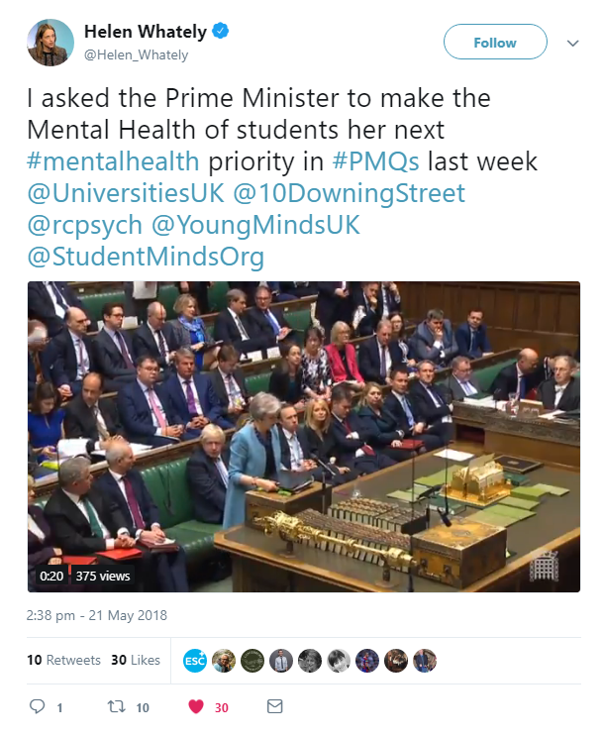
(Source: Twitter 21 May 2018 - https://twitter.com/Helen_Whately/status/998573684540493824)

Dr Dominique Thompson, National Student Mental Health Expert and ex-Director of the University of Bristol Students' Health Service, says: "There has never been a more crucial time for students to have access to reliable, safe, relevant health information. Student numbers are increasing, and demand for health advice and support is also rising. Students need to be able to access credible help fast. The Student Health App provides all of this, on a wide range of topics, from mental and sexual health through to emergencies and travel. They shouldn't leave home without it."
NEW APP DRELEASE: Originally released as 'ESC Student' in 2016, the newly named 'Student Health App' boasts new features such as a more user-friendly home screen, welcome screens for new users and a feature slider providing variable content and links.
The Higher Education Policy Institute said in their report 'Improving Students' Mental Health': "We recommend that higher education institutions advertise the ESC Student app and encourage its use."

WHAT THE APP DOES: With the Student Health App, students will find reliable answers to (almost) all their health questions in plain language – anywhere, anytime and in private. It has been created by doctors together with a panel of students and student health experts from the University of Bristol Students' Health Service.
UNIVERSITY CUSTOMISATION: The new Student Health App can also be customised for universities to signpost to local student services and resources, so students can easily find the support is available to them in their area.
Dr Knut Schroeder, a GP, Honorary Senior Clinical in General Practice at the University of Bristol and Founder of Expert Self-Care, the social enterprise behind the app, said: "The idea for this app started when I was mentoring students and looking after them as patients. The transition into student life can be a real challenge, and knowing what to do next when faced with a physical or mental health problem can be challenging. Being able to access reliable information and knowing that it's okay to seek help early is key for students – and with our app we enable students to answer many common and important health questions all in one place."
APP CONTENTS: Designed for students and every university in the UK as a new free digital resource, the app will also be helpful to international students who may find it hard to navigate the NHS:
- Emergencies – learn the truth about life-threatening illnesses, how to give first aid and when to call an ambulance
- General ill health - tackle sleep problems, feeling stressed and constant tiredness
- Mental health – find out what to do when you feel stressed, low or anxious, or if you self-harm or feel suicidal
- Common ailments and physical symptoms – get to the bottom of headaches, find out how to treat spots, and manage common aches and pains
- Love, sex and relationships - learn about effective contraception, healthy relationships and spotting abuse
- Alcohol & Drugs - recognise the dangers of substance misuse and addictions
- Healthy living - appreciate the importance of a healthy diet and staying physically fit
- Travel and fun – know how to stay safe and healthy on your travels
- Long-term conditions - learn to live with diabetes, asthma and epilepsy and know how to cope with variations in ability
- Safety - stay safe on campus, enjoy nights out, and be travel-smart
- Navigating health services – know when and how to access health professionals such as your pharmacist, nurse or doctor
- Useful links – get fast access to hundreds of links to reliable sources of further information
DOWNLOADING THE APP: The app is free–to-download from the Apple App Store and Google Play.

-ENDS-

NOTES TO THE EDITOR: Dr Knut Schroeder and Dr Dominique Thompson are available for interview:
- Dr Knut Schroeder: knut.schroeder@expertselfcare.com | 0117 9243965 | 07490 765063
- Dr Dominique Thompson: dominique.thompson@me.com |07970119041

ABOUT EXPERT SELF CARE: Expert Self Care Ltd, who developed the app, is a UK social enterprise certified by the NHS England Information Standard as a provider of reliable health information. It is led by practising NHS doctors, and aims to give students and young people access to reliable, clear and useful health information - 'on-the-go' and without the need for an internet connection.

CONTACT:
Dr Knut Schroeder
General Practitioner
Founder and Director, Expert Self Care Ltd
Honorary Senior Clinical Lecturer in General Practice, University of Bristol
Email: knut.schroeder@expertselfcare.com
Tel: 0117 9243965
Mob: 07490 765063
Twitter: @DrKnut and @expertselfcare

